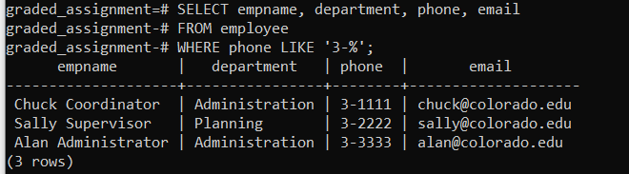

SELECT empname, department, phone, email

FROM employee

WHERE phone LIKE '3-%';